PROJECT REPORT

**ONLINE MOBILE SHOPPING WEBSITE**

Submitted by:-

**DEEPAK BHARDWAJ**

Enroll. No. 00726518118

B.VOC (Software Development)

**5th SEM**



Under the guidance of

And

Submitted to:-

Ms. Swati Rehal

GURU NANAK DEV INSTITUTE OF TECHNOLOGY

Affiliated To

GURU GOBIND SINGH INDRAPRASTHA UNIVERSITY

Acknowledgement

The success and final outcome of this project required a lot of guidance and assistance from many people and I am extremely privileged to have got this all along the completion of my project. All that I have done is only due to such supervision and assistance and I would not forget to thank them.

I respect and thank Ms. Swati Rehal for providing me an opportunity to do the project and giving us all support and guidance which made me complete the project duly. I am extremely thankful to her for providing such a nice support and guidance.

I am thankful to and fortunate enough to get constant encouragement, support and guidance from all Teaching staffs of “Guru Nanak Dev Institute of Technology” which helped me in successfully completing this project work.

*Place: DELHI*

*Date: 14-Dec-2020*

.

*(DEEPAK BHARDWAJ)*

*Enroll No.:* 00726518118

CERTIFICATE

*The project report of* ***DEEPAK BHARDWAJ****(Enroll No.****00726518118****) A Project Report on “****ONLINE MOBILE SHOPPING WEBSITE”*** *is approved and is acceptable in quality and form.*

*Date:*

*Sign:*

Ms. Swati Rehal

*Internal Examiner*

INTRODUCTION

1. Introduction

This project is aimed at developing a Web application that depicts online Shopping of mobiles and purchasing using Payment Gateway. Using this software, companies can improve the efficiency of their services .Online Shopping is one of the applications to improve the marketing of the company’s products. This web application involves all the features of the online shopping.

2. Objective of the project

This software helps customer to find different mobiles, their features, and new updates easily. It is designed such a way that one can view all the updates of the mobile from any place through online. The software will help in easy maintaining and updating products in the website for the administrator. Also quick and easy comparison of different products for the customers.

3. Scope of the project

This system will reduce the manual operation required to maintain all the records of booking information. And also generates the various reports for analysis. Main concept of the project is to enter transaction reports and to maintain customer records. Hence this software can be used in any mobile showroom to maintain their record easily.

4. Further enhancement

This web application involves almost all the features of the online shopping. The future implementation will be online help for the customers and chatting with website administrator.

5. Data Base

The data in the system has to be stored and retrieved from database. Designing the database is part of system design. Data elements and data structures to be stored have been identified at analysis stage. They are structured and put together to design the data storage and retrieval system.

A database is a collection of interrelated data stored with minimum redundancy to serve many users quickly and efficiently. The general objective is to make database access easy, quick, inexpensive and flexible for the user. Relationships are established between the data items and unnecessary data items are removed. Normalization is done to get an internal consistency of data and to have minimum redundancy and maximum stability. This ensures minimizing data storage required, minimizing chances of data inconsistencies and optimizing for updates. The MS Access database has been chosen for developing the relevant databases.

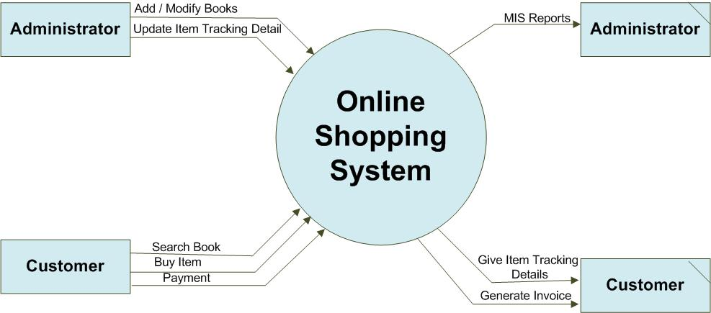**Online Shopping Website (MySQL) :**

6. Testing

System testing is a series of different test whose primary purpose is to fully exercise computer based system.

We can say that it will run according to its specifications and in the way users expect. Special test data are input for processing, and the results examined. A limited number of users may be allowed to use the system so that analyst can see whether they try to use it in unforeseen ways. It is desirable to discover any surprises before the organization implements the system and depends on it.

* We follow Black Box testing.
* Black box testing attempts to find errors in following
* Incorrect or missing function
* Interface errors

OVERVIEW OF ONLINE SHOPPING

The central concept of the application is to allow the customer to shop virtually using the Internet and allow customers to buy the items and articles of their desire from the store.

The information pertaining to the products are stores on an RDBMS at the server side (store). The Server process the customers and the items are shipped to the address submitted by them. The application was designed into two modules first Os for the customers who wish to buy the articles.Second is for the storekeepers who maintains and updates the information pertaining to the articles and those of the customers. The end user of this product is a departmental store where the application is hosted on the web and the administrator maintains the database. The application which is deployed at the customer database, the details of the items are brought forward from the database for the customer view based on the selection through the menu and the database of all the products are updated at the end of each transaction. Data entry into the application can be done through various screens designed for various levels of users. Once the authorized personnel feed the relevant data into the system, several reports could be generated as per the security.

**e-Shopping**

[Online shopping](http://en.wikipedia.org/wiki/Online_shopping) is a form of electronic commerce where the buyer is directly online to the seller's computer usually via the internet. There is no intermediary service. The sale and purchase transaction is completed electronically and interactively in real-time such as Amazon.com for new books. If an intermediary is present, then the sale and purchase transaction is called electronic commerce such as [eBay.com](http://en.wikipedia.org/wiki/EBay.com).

Proposed System:

The development of this new system contains the following activities, which try to develop on-line application by keeping the entire process in the view of database integration approach.

* Secure registration and profile management facilities for Customers.
* Browsing through the e-Mall to see the items that are there in each category of products like Mobile phones, Phone accessories, Laptop accessories, laptop etc.
* Creating a Shopping cart so that customer can Shoppe ‘n’ no. of items and checkout finally with the entire shopping cart
* Customers should be able to mail the Shop about the items they would like to see in the Shop
* Secured mechanism for checking out from the Shop( Credit card verification mechanism )
* Updates to customers about the Recent Items in the Shop.
* Uploading ‘Most Purchased’ Items in each category of products in the Shop like , accessories, brand , latest models etc.

Number of Modules

The system after careful analysis has been identified to be presented with the following modules:

1. Customer.
2. Admin Module.
3. Security and Authentication

Software Requirements

Operating System : Windows XP/7/8/8.1 or Linux

User Interface : HTML, CSS

Server-side Scripting : PHP Script

Client-side-Scripting : Java Script

Programming Language : PHP

Web Applications : Wamp Server

IDE/Workbench : Net Beans

Database : MySQL

Server Deployment : Apache

Hardware Requirements

Processor : Pentium IV

Hard Disk : 40GB

RAM : 512MB or more

System Analysis & Design

SELLER

BUYER

**Database Tables**

* **Login/ socially & Mannually**
* **Change passward**
* **Product**

Data flow Diagram

* **A data flow diagram (DFD) is a graphical representation of the "flow" of data through an information system.**



Home Page



Products

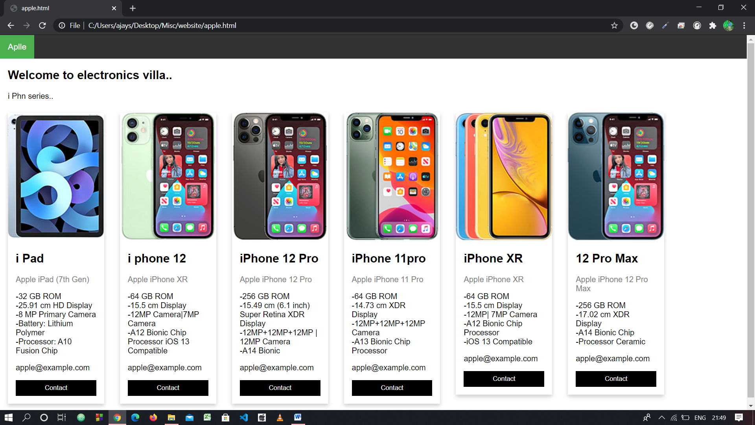

Contact

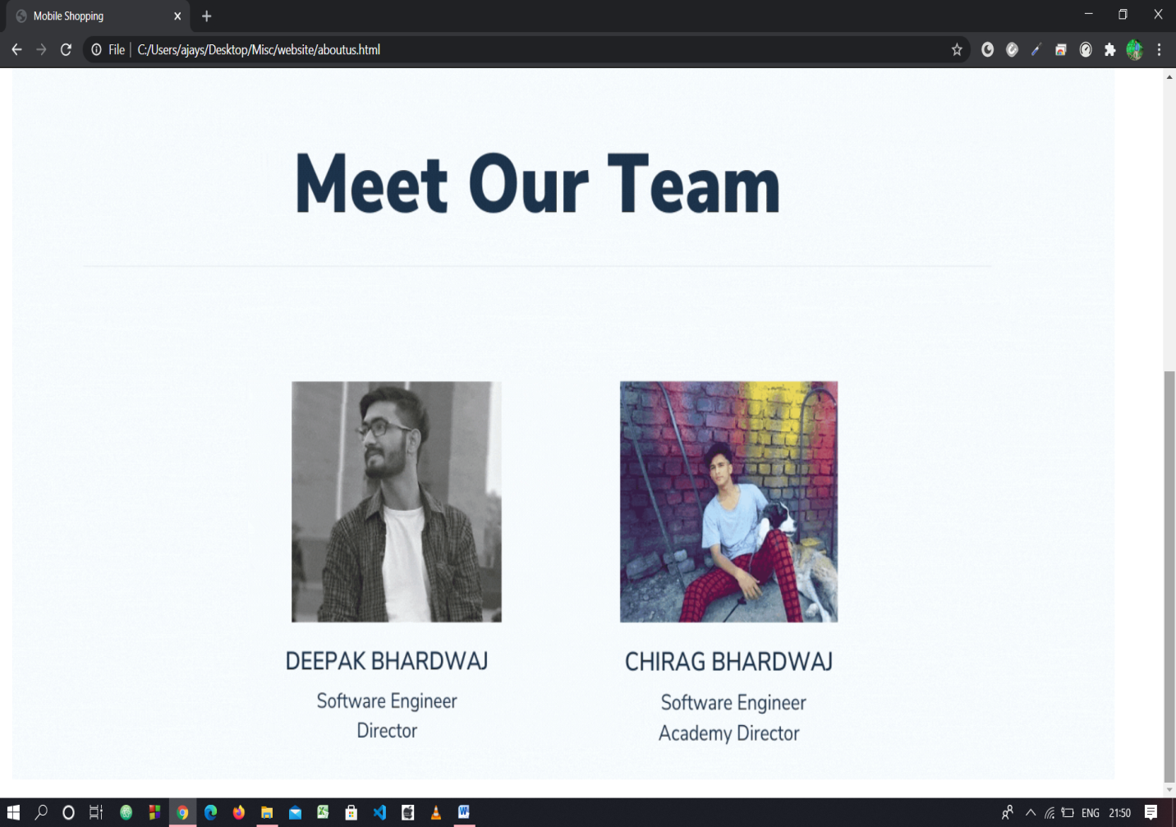

Database

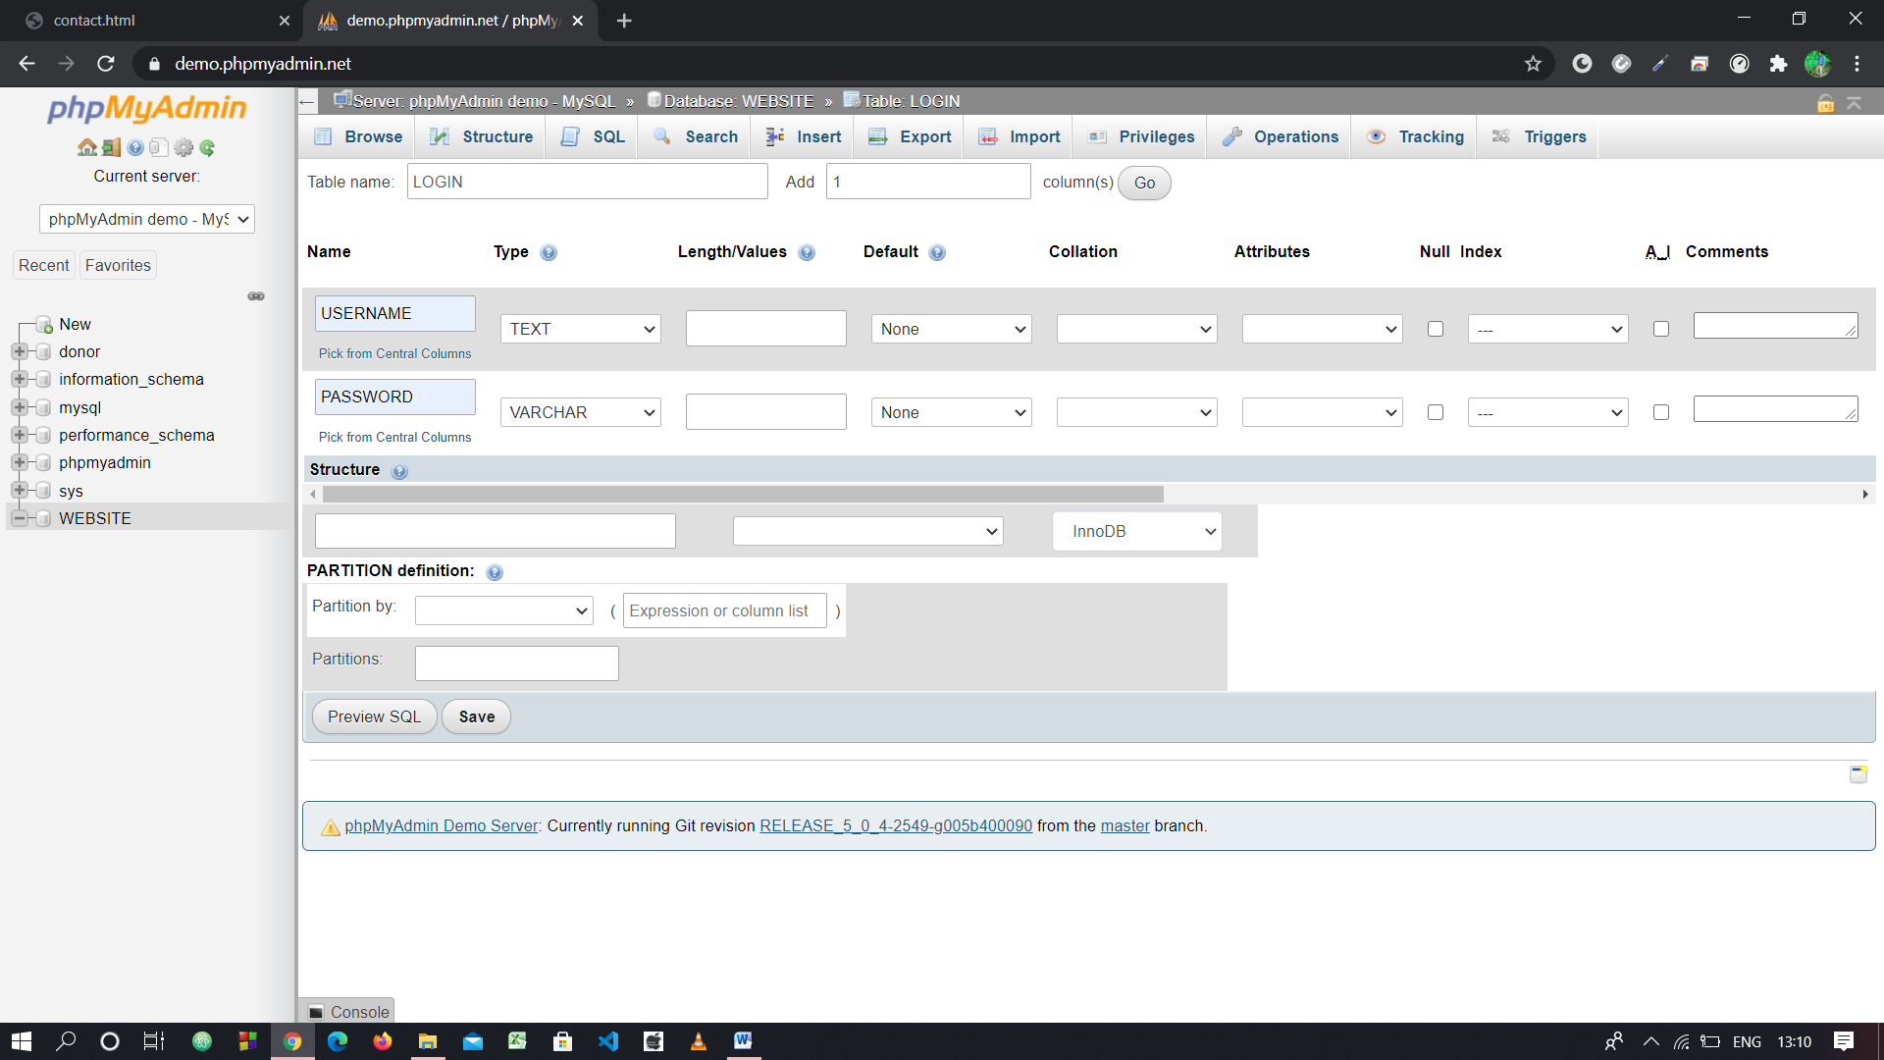

Cart

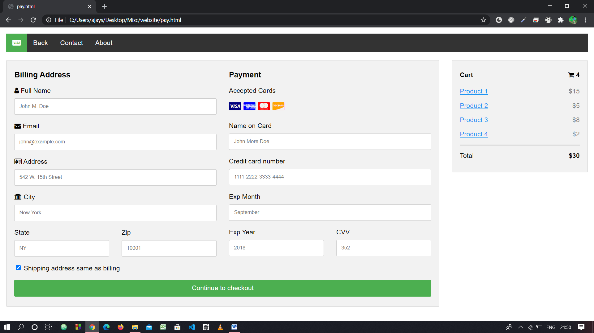

Services

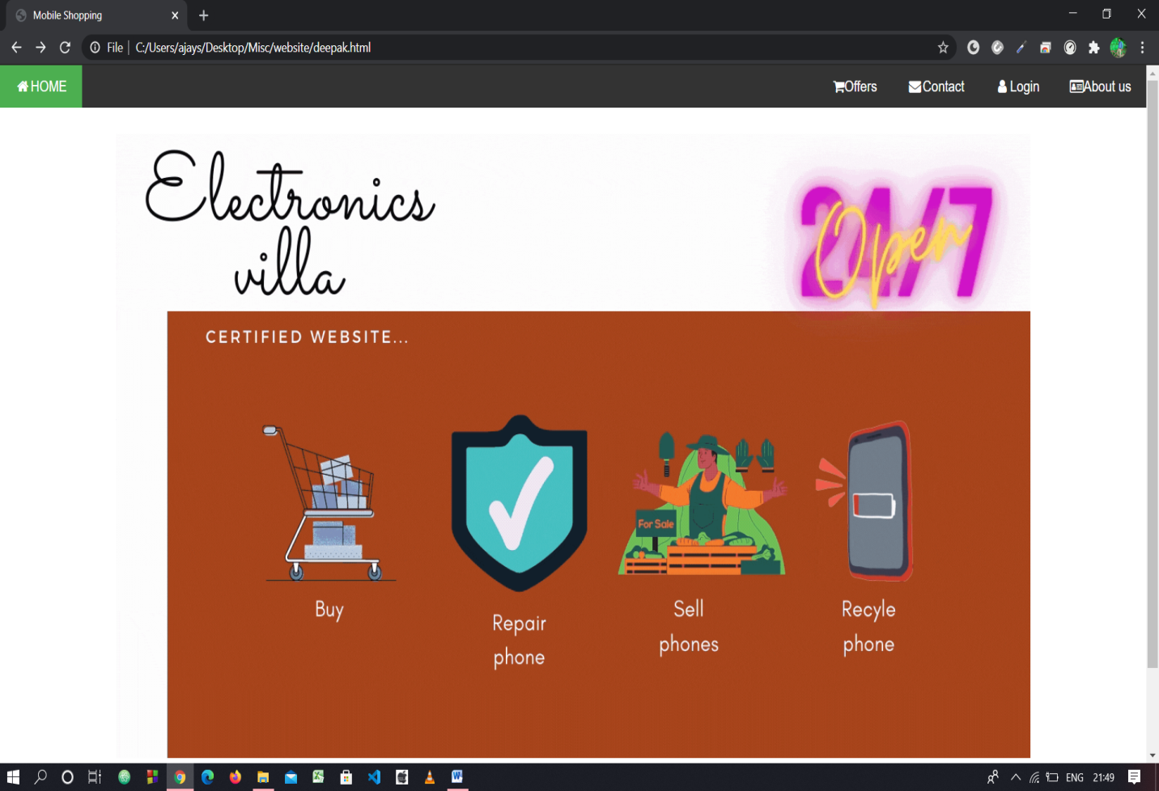

Login page

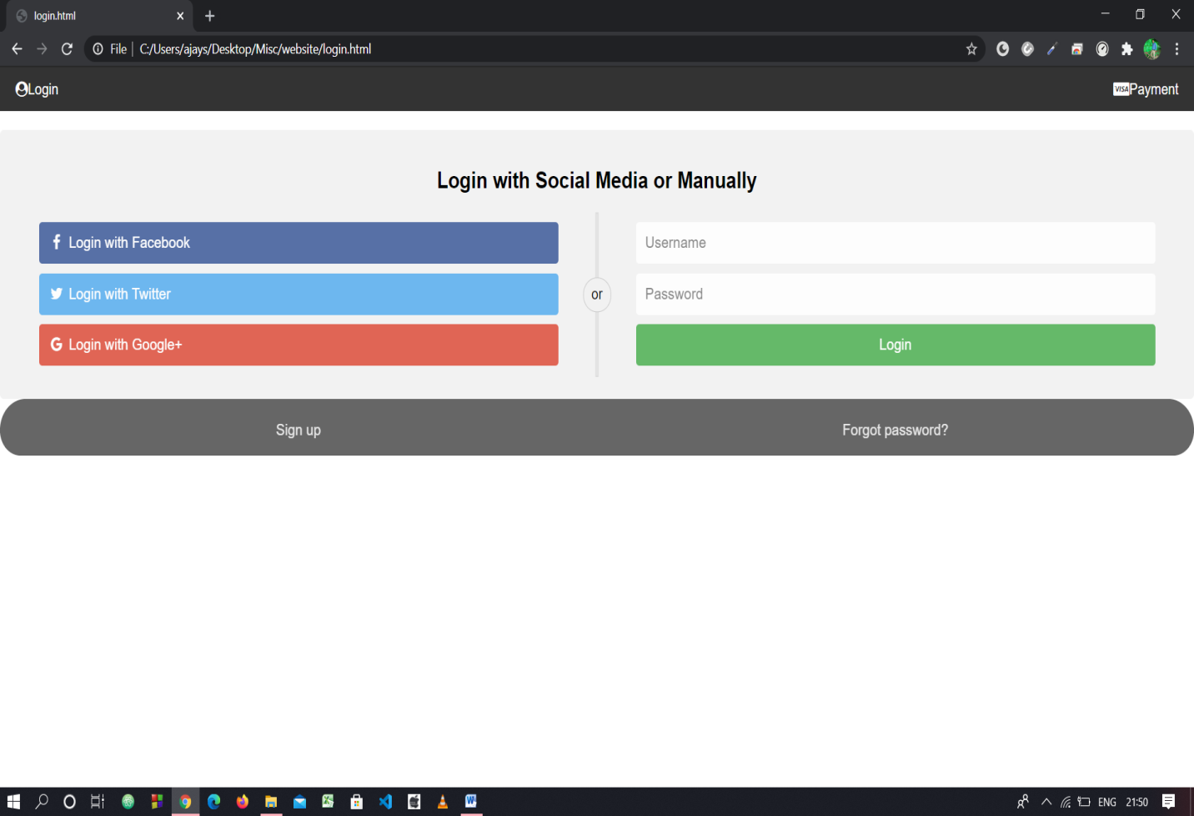

About us

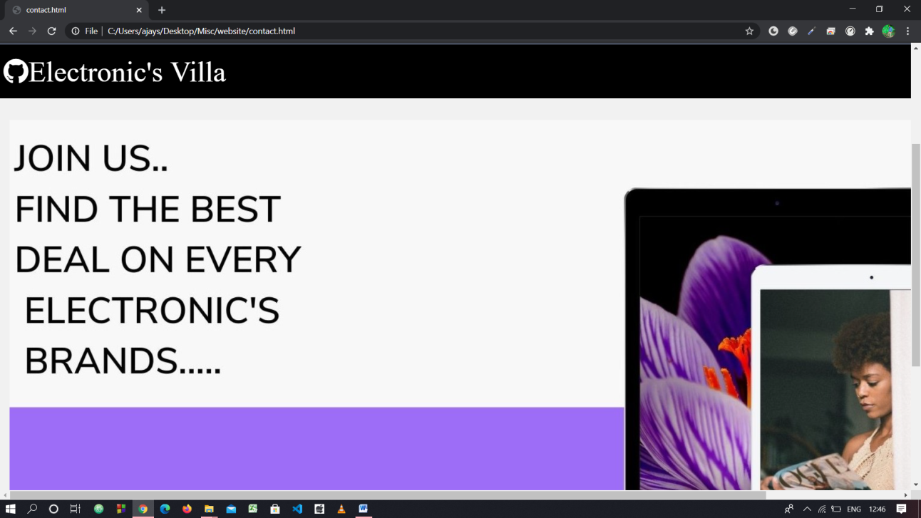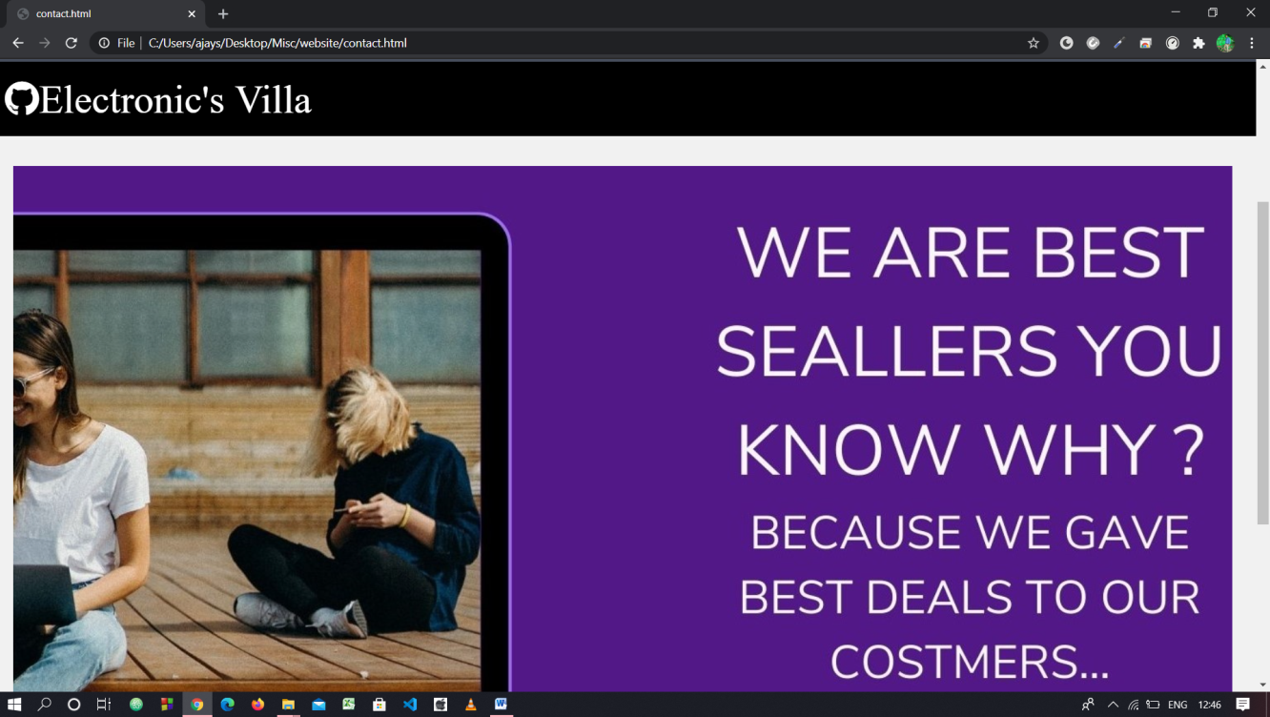

Brands

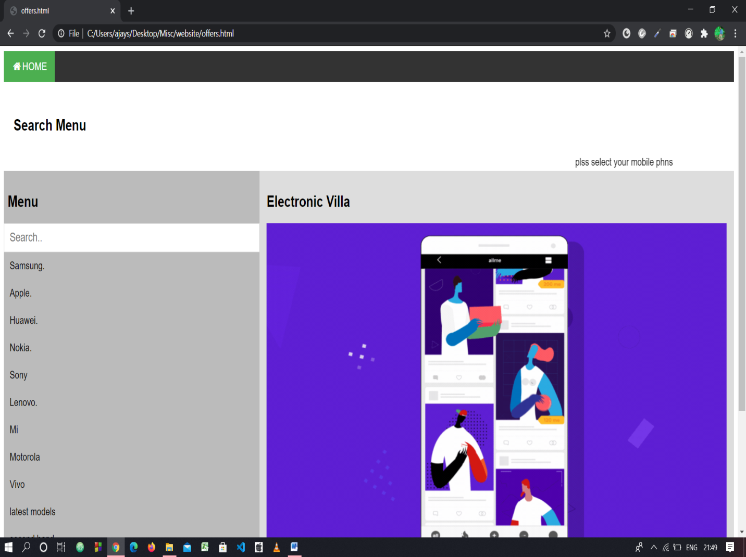

Social Accounts

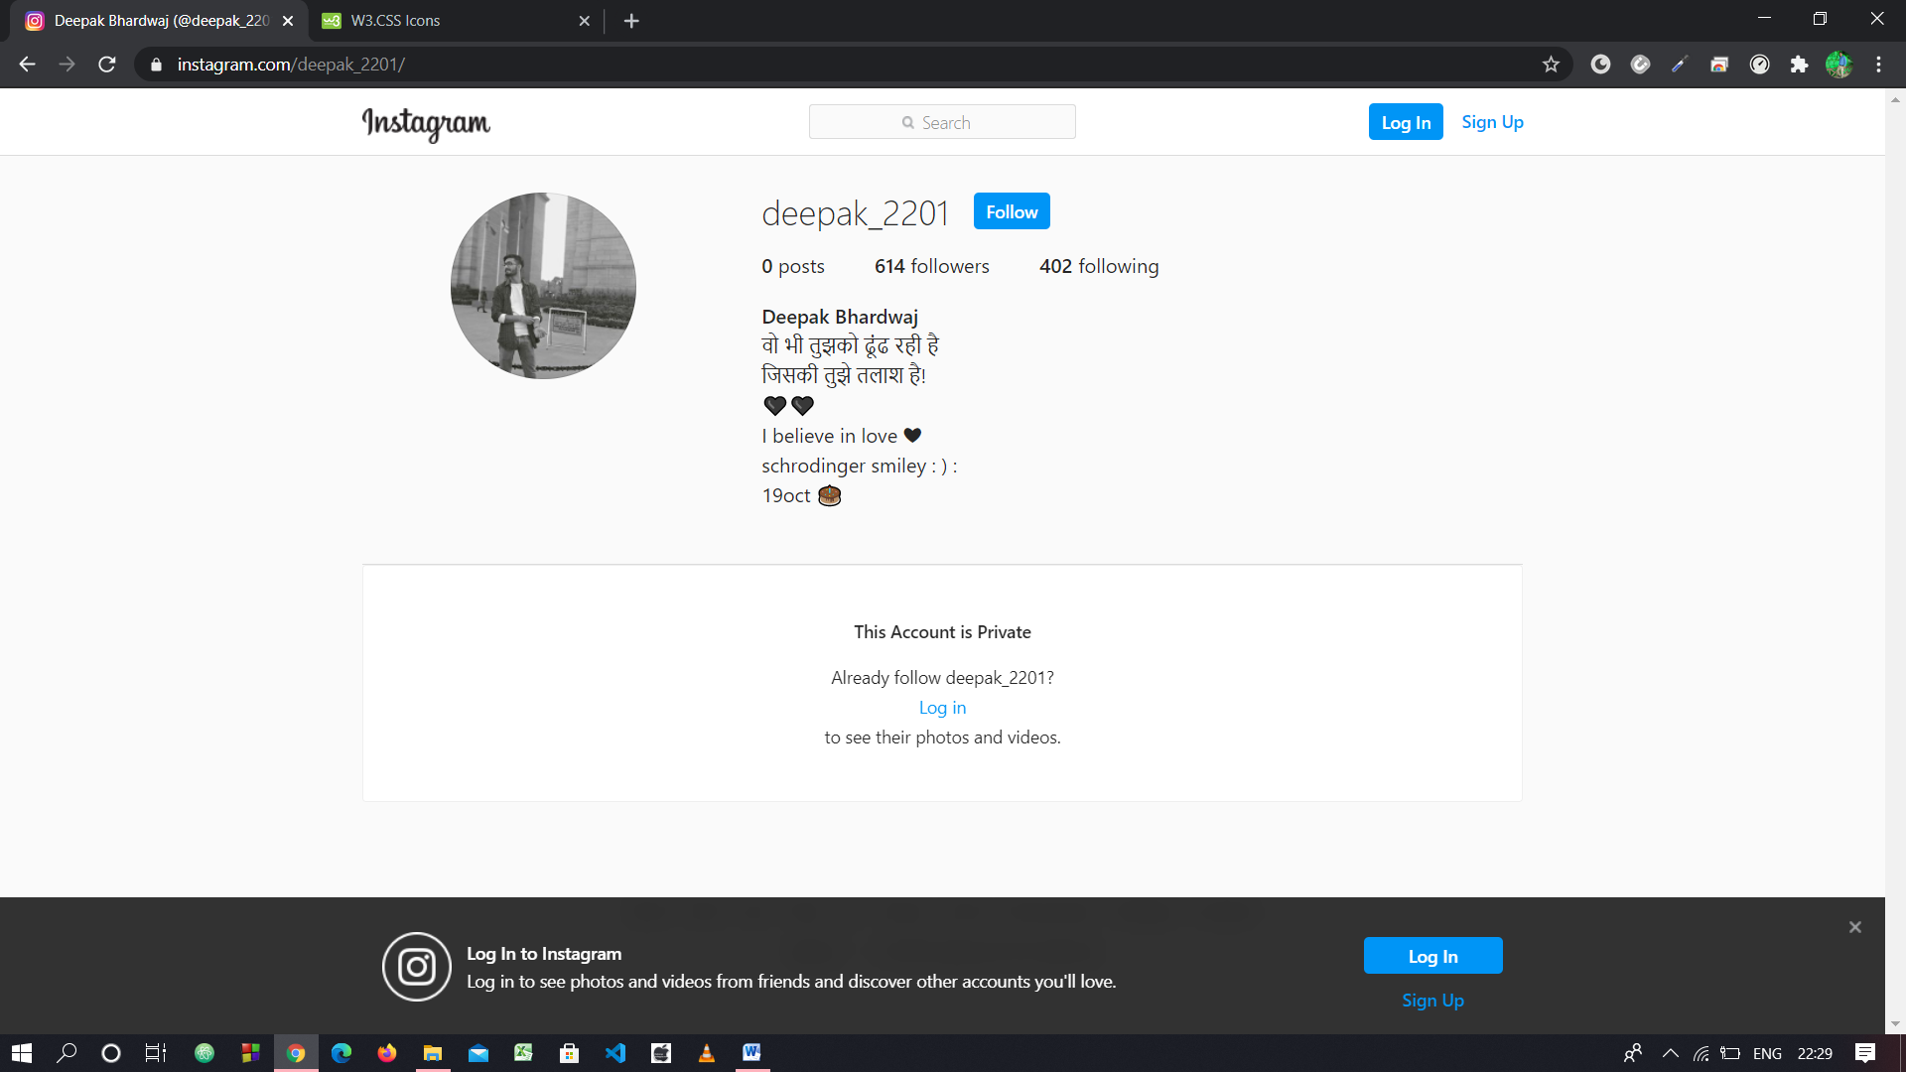

INTERPRETATION OF THE RESULT

The system has been implemented and tested successfully. It meets the information requirements specified to the great extent. although the system has been designed keeping the present and future requirements in mind and made very flexible.

There are limitations of the system. proper consideration has been given for a wide range of new enhancements.The system is developed user friendly.In future , if it is required to generate reports other than provided by the system it can be simply achieved by a separate module to the main menu without affecting the design of the system.

ADVANTAGES

(1)it simplifies the operation.

(2)it avoids a lot of manual work.

(3)every transaction is obtained and processed immediately.

(4)avoids errors by avoiding the manual work.

(5)user friendly screen to enter the data and enquire the database tables.

(6)online help messages available to the operating system.

(7)user can easily access the system without much experience.

(8)provide hardware and software securities.

(9)portable and flexible for further extensions.

Conclusion

The central concept of the application is to allow the customer to shop virtually using the Internet and allow customers to buy the items and articles of their desire from the store.

The information pertaining to the products are stores on an RDBMS at the server side (store).The Server process the customers and the items are shipped to the address submitted by them.

The application was designed into two modules first Os for the customers who wish to buy the articles. Second is for the storekeepers who maintains and updates the information pertaining to the articles and those of the customers.

The end user of this product is a departmental store where the application is hosted on the web and the administrator maintains the database. The application which is deployed at the customer database, the details of the items are brought forward from the database for the customer view based on the selection through the menu and the database of all the products are updated at the end of each transaction.

The project entitled “Online Mobile Shopping” is developed using ASP.Net as front end and SQL Server database in back end to computerize the process of online buying and selling of mobiles in a showroom. This project covers only the basic features required.

REFERENCES

1.<https://www.youtube.com/watch?v=v1otHJGlV5g&list=PLuIr1FMHB3x3HRtWm_-bUOJ2I6tRnPS06>

2. <https://www.youtube.com/watch?v=GvUTqsAm9vE&list=PLamqHyWseJOIliSZ23WDS1Ky-uU5yrjOk>

3.https://www.youtube.com/watch?v=5sxtZ10Vf3s&list=PLbGui_ZYuhihSr4HroBBQt_quHL42JLif

4.https://www.youtube.com/watch?v=3qti7Vof_7Q&list=PLbGui_ZYuhiiaQjuOfvgx_-gzVBlCxrk0

For MySQL (DATA BASE)

<https://www.mysql.com/>

[http://www.mysqltutorial.org](http://www.mysqltutorial.org/)

***Thank You***